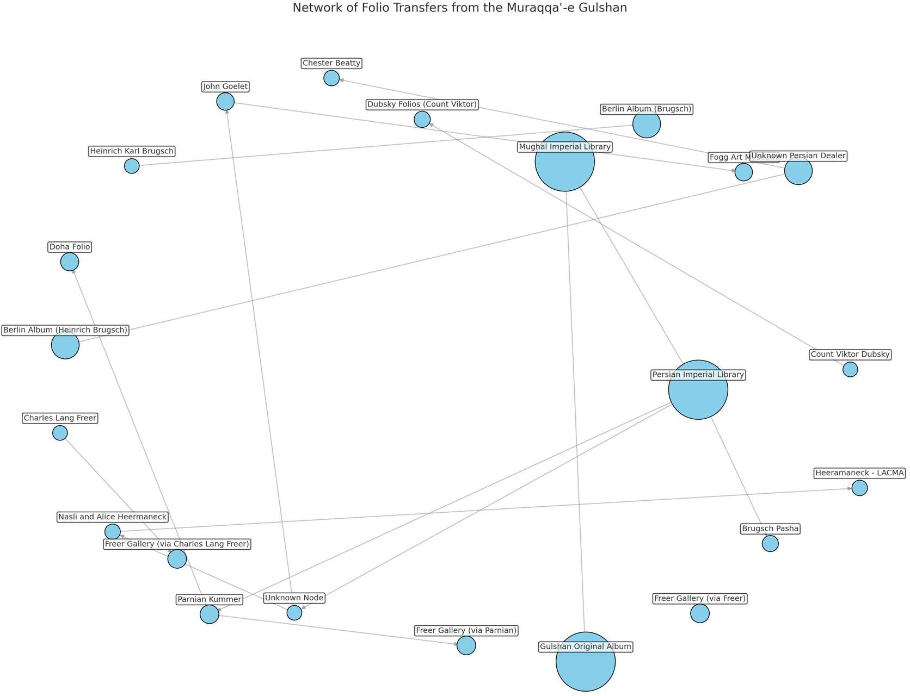

Figure 02: Node size corresponds to the number of folios held, visually emphasizing major collecting hubs such as the Persian Imperial Library and the Berlin State Library. Directional edges trace documented and inferred transfers, with an “Unknown Dealer/Collector” node representing uncertain intermediaries in the pathway from the Persian Imperial Library to figures like John Goelet and Nasli and Alice Heermaneck. This visualization highlights the fragmented and multi-scalar nature of manuscript circulation across time and space. This refined network underscores the importance of digital graph modeling in tracing fragmented manuscript histories. It also foregrounds the interpretive labor required to account for gaps in documentation, especially when addressing manuscripts that changed hands in informal or colonial-era markets.

